Tapping Mechanisms
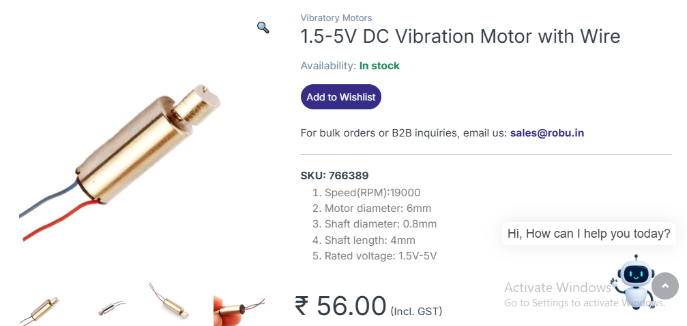
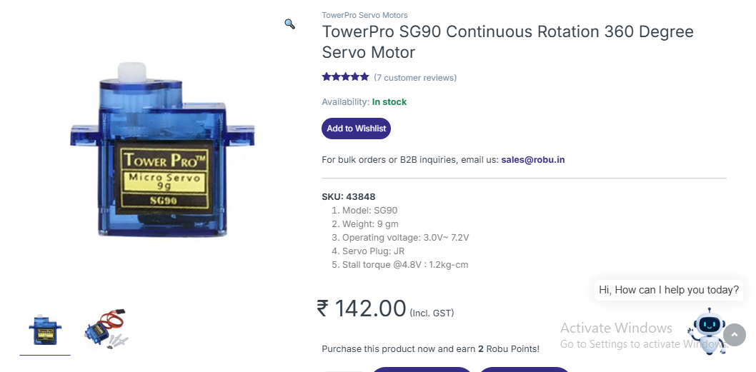
Actuator | Typical unit price (India) | Impact strength | Stroke / behavior | Control & timing | Power | Good for AE tapping?
Flat coin vibrator (e.g. Flat 1034) | ₹50–₹150. Small phone coin motors widely available. (Sharvie Electronics) | Low — vibration, not strong impulse | Very small oscillation; convert via lever/spring to make taps | PWM on MCU, very simple | ~60–100 mA @ 3V | Good for light taps / excitation; cheapest option
Cylindrical / larger ERM vibrator | ₹70–₹200 depending on size. (Robu) | Medium — stronger vibration, more torque | Small linear/rotational amplitude; better momentum than coin | PWM, simple drive | 50–200 mA | Better than coin for larger taps; low cost
Micro-servo (e.g. SG90) | ₹70–₹140 (hobby grade). Precise angular control. (QuartzComponents) | Medium — depends on lever/cam design (can amplify force) | Large controllable stroke (degree rotation) | PWM position control (precise) | ~200–500 mA peaks | Good if you need controlled tap timing/position — needs mech. linkage
Mini solenoid (5 V) | ₹300–₹2000 (small types ~₹300–600 online). (MG Super Labs) | High — clear percussive impact | Direct linear stroke; repeatable | On/off via MOSFET; very repeatable | 0.5–1 A (short duty) | Best for strong, repeatable taps; higher cost & driver required

